Report: Australian and New Zealand Journal of European Studies (ANZJES)
ESAANZ AGM, 18 May 2026

Publications in 2025
The journal published three issues during 2025.
- 17(1): an open issue, which also included policy briefs produced by students of the University of Melbourne’s Faculty of Education;
- 17(2): a special issue stemming from a conference of the Australasia Association for Euro-Asian Studies (AAEAS);
- 17/3: an open issue.

In 2026, we are anticipating a further three issues:
- 18(1): an open issue;
- 18(2): a special issue titled ‘Digital heritage diplomacy in conflicts and crises: Ukrainian identity in the narratives of digital diplomacy’ to be guest edited by Svitlana Zhabotynska, Natalia Zemzyulina and Daria Kuznetsova;
- 17(3): a special issue titled ‘European Union Trade Policy: Fluctuating waves since Maastricht’ to be guest edited by Bruno Mascitelli and Kaye Quek.

Submissions
We continue to receive a steady stream of submissions, including proposals for special issues.

We received 62 submissions during 2025 (which includes non-peer reviewed student work). Of these, 27 were subsequently published, with 35 being declined: 14 desk rejections (as not being with the aim and scope of ANZJES, or for having been published elsewhere); and 11 declined following peer review.

A contributing factor to the large number of rejections in 2025 was the decision by the Editorial Board to abandon a special issue on ‘Governance and public administration amidst war: Ukrainian experience’, for which 13 submissions had been received. Problems with the peer review process coordinated by the guest editors for that issue led to this Board decision.

Readership
Readership numbers have been firm in 2025 (see Table 1). As a Diamond Open Access journal, our articles are available at no cost to readers. Being Scopus indexed, this is an important contribution made by ESAANZ via ANZJES to the academic community in our region.
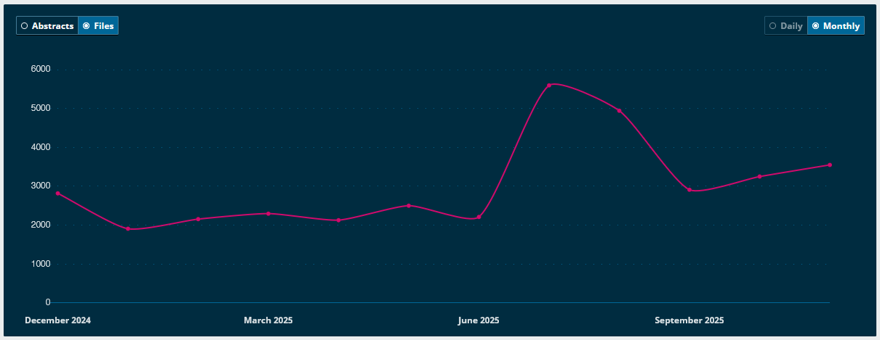
Table 1: ANZJES Article Downloads 2025

Board Changes
In June, Prof Marco Brunazzo of the University of Trento stepped down from the Editorial Board. Marco had taken on extra responsibilities as Head of Department, and therefore found it difficult to give the journal the attention needed. Marco’s contribution to ANZJES was highly valued, and the appreciation of the Editorial Board is extended to him.

In November, Dr Katarzyna (Kasia) Kwapisz Williams, Deputy Director of the Centre for European Studies at ANU, joined the Editorial Board. Kasia has a long association with ESAANZ, and is a valuable addition to the ANZJES editorial team.

The current Editorial Board comprises:
- Dr Mathew Doidge (Editor-in-Chief) – University of Canterbury, New Zealand
- A/Prof. Alexandr Akimov – Griffith University, Australia
- Prof. Natalia Chaban – University of Canterbury, New Zealand
- A/Prof. Gosia Klatt – University of Melbourne, Australia
- Prof. Peter Morgan – University of Sydney, Australia
- Dr Katarzyna Kwapisz Williams – ANU, Australia
- Dr Maren Klein (Copy Editor)

Challenges
Copyediting and production remained a challenge in 2025. These substantial tasks fall largely on the shoulders of our sole copy editor Maren Klein. It is proving a challenge to find additional persons with the requisite skill-set willing to volunteer their time to assist in the copyediting process.

Thanks to Editorial Board
As Editor-in-Chief, I would like to offer my personal thanks to the members of the Editorial Board for their work in 2025, and note the particular contribution of Maren Klein, who copy edits the majority of our manuscripts. The hard work of the Board has been essential to the success of the journal.

Dr Mathew Doidge
Editor-in-Chief, ANZJES
15 May 2026

